Statistics and Data Analysis Final Paper

Kaleigh Webber
School of Information
INF 6490: Statistics and Data Analysis
Professor Smith
December

Introduction
The “mtcars” dataset is a built-in dataset in R, originally sourced from a 1974 edition of Motor Trend. It contains fuel consumption and automobile performance characteristics for thirty-two car models, including variables such as miles per gallon (mpg), horsepower (hp), weight (wt), number of cylinders (cyl), and transmission type (am). The primary objective of this analysis is to determine which vehicle characteristics significantly influence fuel efficiency and build a predictive model capable of estimating mile per gallon (mpg) based on these characteristics.
Specifically, this analysis addressed four research questions: (1) which variables are most strongly correlated with fuel efficiency, (2) whether cars with automatic and manual transmissions differ significantly in mpg, (3) whether mpg can be predicted using weight, horsepower, number of cylinders, and transmission type, and (4) how accurate a linear regression model is at predicting fuel efficiency.
Data Cleaning
After loading in the dataset, the analysis began with an inspection of the dataset’s structure and summary of statistics. No missing values were found, making the dataset suitable for immediate analysis. Several variables representing categorical data, including number of cylinders, transmission type, number of gears, and number of carburetors, were converted into factor variables to ensure appropriate handling in statistical test and regression modeling.
Outliers were examined using boxplots statistics for miles per gallon (A.1), weight (A.2), and horsepower (A.3). Some extreme outliers were observed in weight and horsepower. However, these were kept. Given the small sample size and the fact that these values reflect real-world vehicles, as opposed to data errors, removing them could distort the analysis.
Descriptive Statistics
Descriptive statistics were computed to summarize the key characteristics of the dataset. Fuel efficiency (mpg) ranges from 10.4 to 33.9 miles per gallon, with an average of roughly 20.1 mpg. Horsepower and vehicle weight show substantial variations, reflecting the diversity of vehicles included in the dataset.
Regarding the categorical variables, most of the vehicles in the dataset are equipped with eight-cylinder engines. Manual transmission vehicles account for nearly forty percent of the sample, while the remaining vehicles are automatic transmissions.
Visualizations
Data visualizations were used to explore univariate and multivariate relationships. Histograms and boxplots illustrated the distribution of key variables such as miles per gallon (A.4) (mpg) and horsepower (A.5), while bar plots highlighted the frequency of different cylinders (A.6).
Multivariate plots (A.7) and correlation matrices (A.8) revealed clear relationships among the variables. Vehicle weight and engine displacement appear to have a strong negative correlation with fuel efficiency, indicating that heavier cars tend to achieve lower mpg. Similarly, cars with more cylinders generally have poorer fuel efficiency.
Statistical Tests
Pearson correlation tests were conducted to quantify the relationship between mpg and selected continuous variables. Vehicle weight indicated a strong and statistically significant negative correlation with mpg, while horsepower also showed a significant negative relationship with fuel efficiency.
To evaluate the differences in fuel efficiency by transmission type, a two-sample t-test was performed comparing mpg between automatic and manual transmissions. The results showed that cars with manual transmissions have a significantly higher average mpg than those with manual transmissions. Indicting that transmission type plays an important role in fuel efficiency.
A linear regression model was used to predict miles per gallon using vehicle weight, horsepower, number of cylinders, and transmission type as predictors. The dataset was split into training and testing subsets to evaluate predictive performance. Results indicate that vehicle weight is the strongest predictor of mpg, with heavier cars experiencing significantly lower fuel efficiency. Horsepower also had a negative effect on mpg.
Transmission type remained a meaningful predictor even after controlling for weight and horsepower, with manual transmissions associated with higher fuel efficiency. Model predictions were evaluated using root squared error (RMSE), which indicated a moderate predictive accuracy given the small size of the dataset.
Conclusions
Analysis of this dataset identified strong relationships between vehicle characteristics and fuel efficiency. Weight and horsepower both have a highly negative correlation with mpg, indicating that heavier and more powerful cars tend to consume more fuel. The transmission type also plays a meaningful role. Manual cars achieve significantly higher mpg than automatic cars.
The linear regression model confirmed these findings. Weight emerged as the largest negative predictor, and transmission remained significant even after adjusting for other variables. Although the model performed reasonably well, its predictive accuracy is limited by the small sample size and the age of the data. The vehicles in the dataset are from 1974 and may not reflect the design, technology, and/or efficiency of modern vehicles. Future research could extend this analysis by applying more advanced regression techniques or using a larger and more modern dataset to improve generalizability and predictive performance.
Appendix
R Script
#Load Dataset
data(mtcars)
df <- mtcars

#Inspect Data
str(df)
summary(df)

#Convert Categorical Variables to Factors
df$cyl <- as.factor(df$cyl)
df$am <- as.factor(df$am)
df$gear <- as.factor(df$gear)
df$carb <- as.factor(df$carb)

#Check for Missing Values
colSums(is.na(df))

#Detect Outliers Using Boxplots

#Boxplot for MPG (miles per gallon)
boxplot(df$mpg, main = "Boxplot of MPG", ylab = "MPG")
cat("Outliers for MPG: ", boxplot(df$mpg, plot = FALSE)$out, "\n")

#Boxplot for WT (weight)
boxplot(df$wt, main = "Boxplot for WT", ylab = "WT")
cat("Outliers for WT: ", boxplot(df$wt, plot = FALSE)$out, "\n")

#Boxplot for HP (horsepower)
boxplot(df$hp, main = "Boxplot for HP", ylab = "HP")
cat("Outliers for HP: ", boxplot(df$hp, plot = FALSE)$out, "\n")

#Scale Continuous Features
scaled_df <- as.data.frame(scale(df[, c("hp","wt","disp")]))
library(psych)

#Continuous Variables
describe(df[, c("mpg","hp","wt","disp")])

#Categorical Frequency Tables
table(df$cyl)
prop.table(table(df$am))

#Univeriate Plots
hist(df$mpg, main = "MPG Distribution", col = "lightblue")
boxplot(df$hp, main = "Horsepower Boxplot")
barplot(table(df$cyl), main = "Cylinders", col = "orange")

#Multivariate Plots
pairs(df[, c("mpg","hp","wt","disp")])
library(corrplot)
corrplot(cor(df[, c("mpg","hp","wt","disp")]), method = "color")

#Test Correlations
cor.test(df$mpg, df$wt)
cor.test(df$mpg, df$hp)

#T-Test: Transmission Type vs MPG
t.test(mpg ~ am, data = df)

#Train/Test Split
set.seed(123)
index <- sample(1:nrow(df), size = 0.7*nrow(df))
train <- df[index, ]
test <- df[-index, ]

#Build Model
model <- lm(mpg~wt + hp + cyl + am, data = train)
summary(model)

#Predict and Evaluate
pred <- predict(model, newdata = test)

#Compute RMSE
rmse <- sqrt(mean((pred - test$mpg)^2))
rmse

Visualizations
A.1 – Boxplot for Mile per Gallon (mpg) Outliers
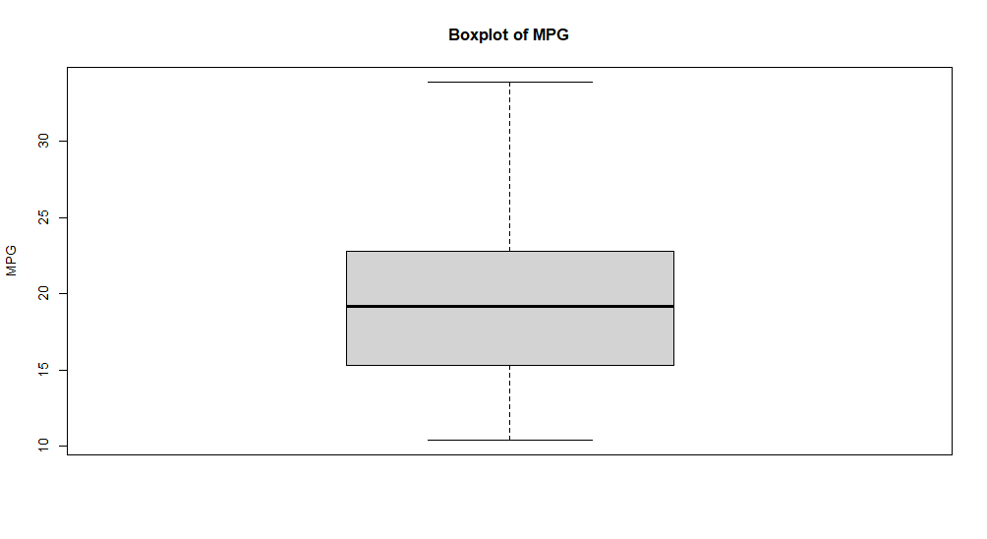

A.2 – Boxplot for Weight (wt
) Outliers
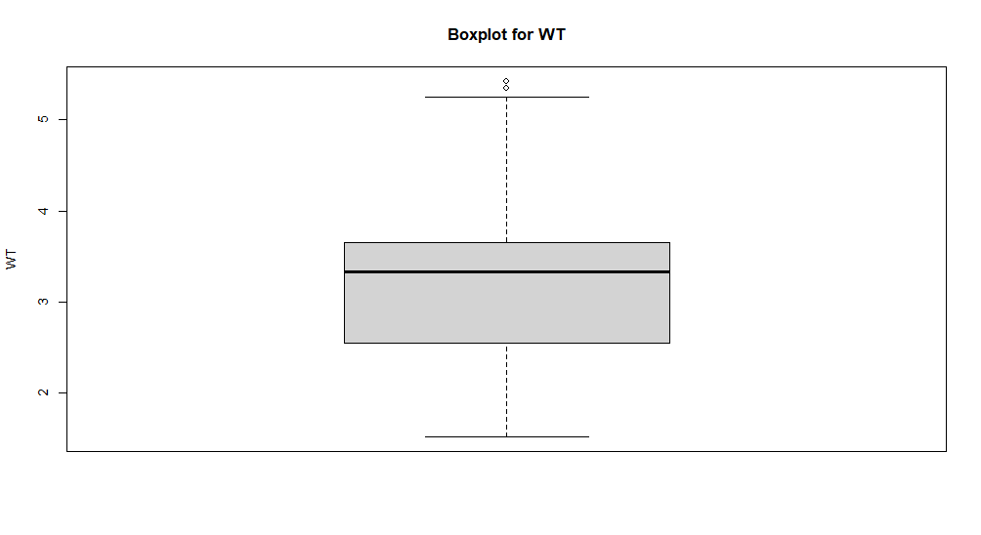

A.3 – Boxplot for Horsepower (hp) Outliers
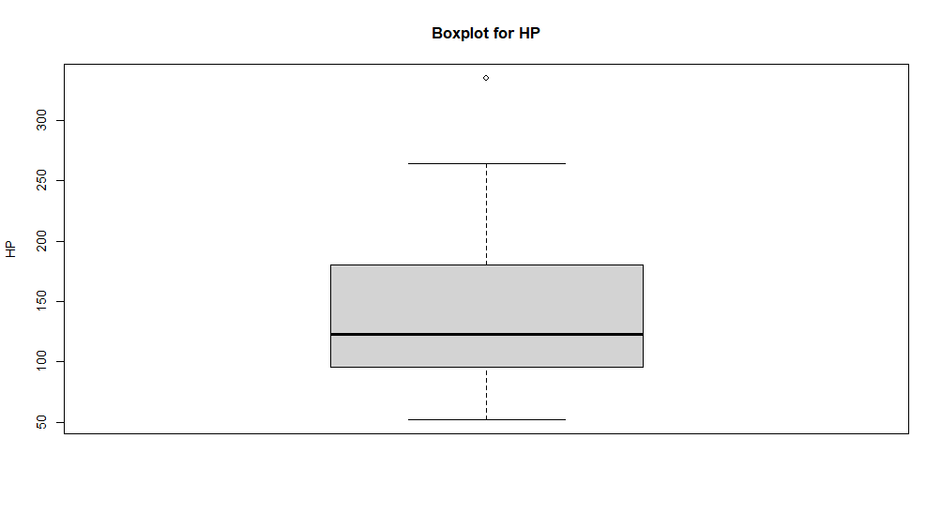

A.4 – MPG Histogram
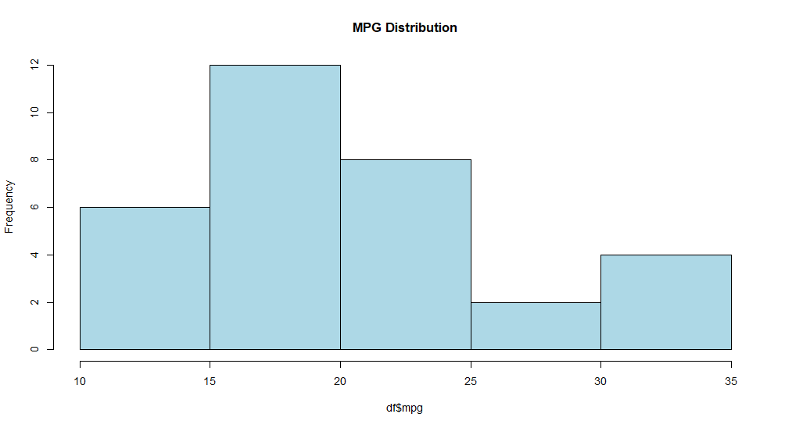

A.5 – Horsepower Boxplot
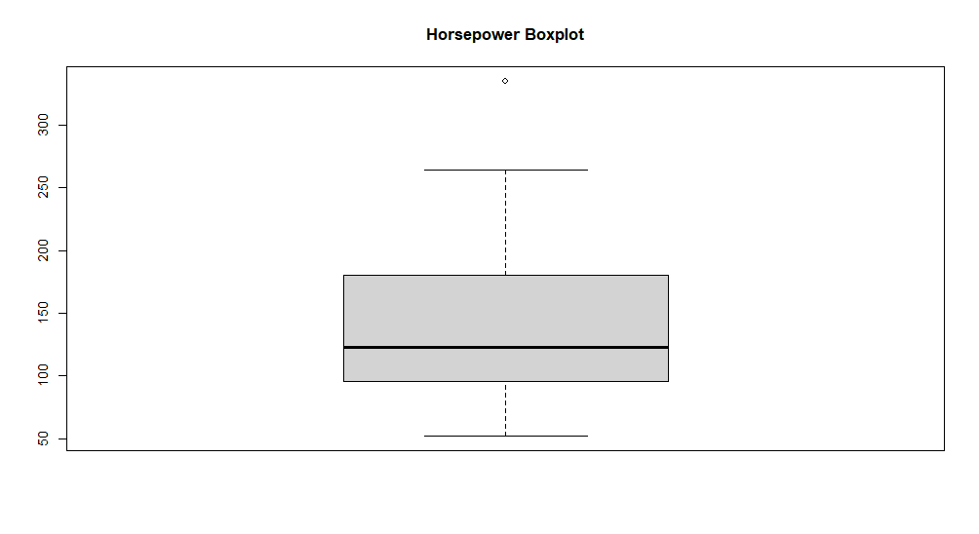

A.6 – Number of Cylinders Bar Plot
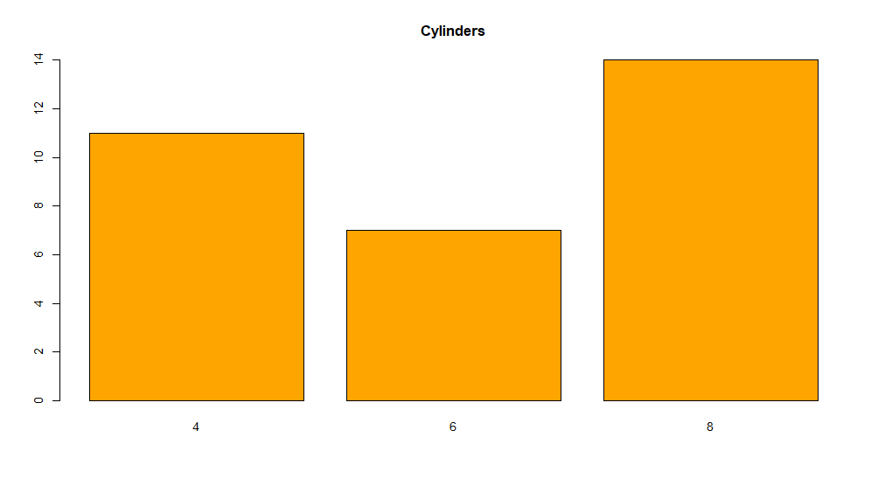

A.7 – Multivariate Plots
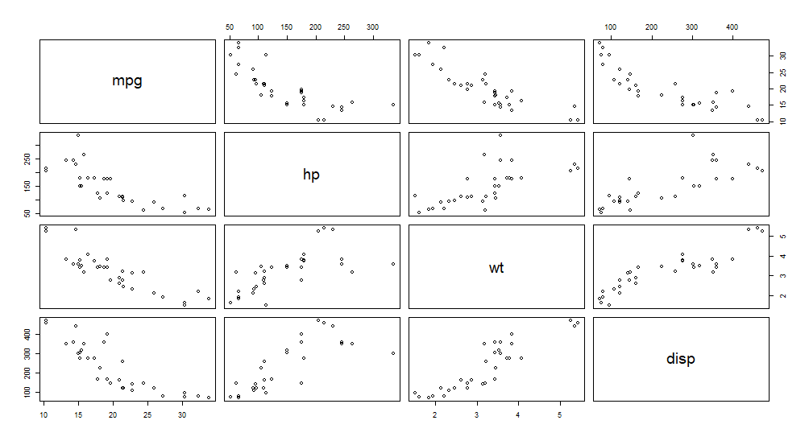

A.8 – Correlation Matrices

